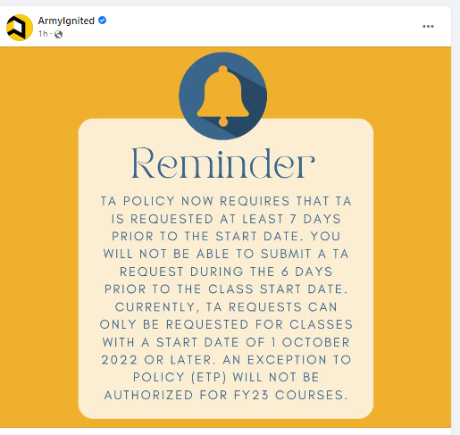

[https://www.armyignited.army.mil](https://l.facebook.com/l.php?u=https%3A%2F%2Fwww.armyignited.army.mil%2F%3Ffbclid%3DIwAR13XCSjY-YSdaXwi5g0aSTe5Sp26hN7ordp6q6QQ-1LwWukpctZCFozJEk&h=AT0C3xn0SncP5ncsJlYliZ7NgMcm9qhBwA5t3kjeiA3SVruB2pZnmVS4JYUfG9Je_jZo5w2SuTeheGsBnFkRHKypkHBvcj8_IpwuKTxzTGcLBW9-iTnNp-P_r54A59r8Mg&__tn__=-UK-R&c%5b0%5d=AT0x5L_-1I5C5-bteNARHPkIXeyJOgz89D6t9MfdUvPh0DZxZ2LBD_8HEjfxXoisNHiIq0cxRLZH1N8-LwcA8wHLjltgt8YbnWK-5Xhelqd7spLmJUIjm7vrLesFGIXW5sjgWaMXbmwPIrTEAecAFcu4Ig" \t "_blank)

